Karriem S. Watson, DHS, MS, MPH
All of Us Research Program
Chief Engagement Officer
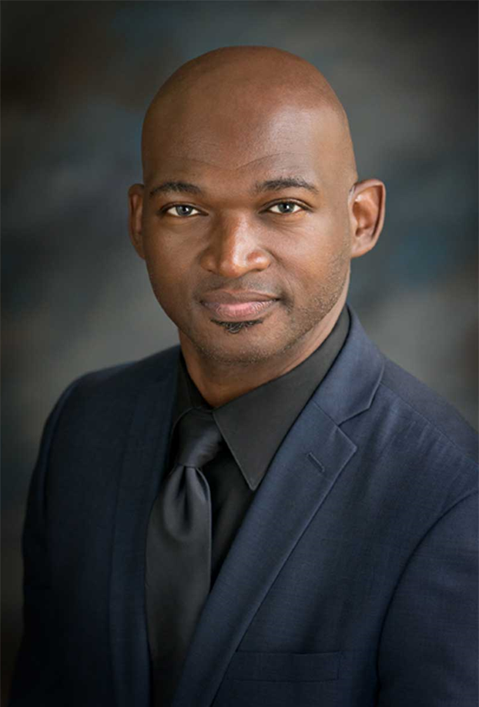
Karriem Watson, D.H.Sc., M.S., M.P.H., is the chief engagement officer of the All of Us Research Program at the National Institutes of Health. In this role, he leads the Division of Engagement and Outreach, overseeing the program’s efforts to foster relationships with participants, community partners, researchers, and providers across the United States. His focus is on engaging people and populations who have been left out of medical research in the past and inviting them to help drive new biomedical discoveries.
Karriem comes to All of Us from his role as associate executive director of the Mile Square Health Center, a group of Federally Qualified Health Centers in Chicago affiliated with the University of Illinois Hospital and Health Sciences System. He served as the associate director of community outreach and engagement for the University of Illinois Cancer Center and as a research assistant professor in the University of Illinois Chicago (UIC) School of Public Health. Much of Karriem’s previous work has focused on cancer, touching on racial disparities in lung cancer, improving cancer survival, and prostate cancer among African American men.
Karriem holds a Doctorate in Health Science (Global Health), a Master of Science in Basic Medical Research, and a Master’s in Public Health (Community Health Sciences).

