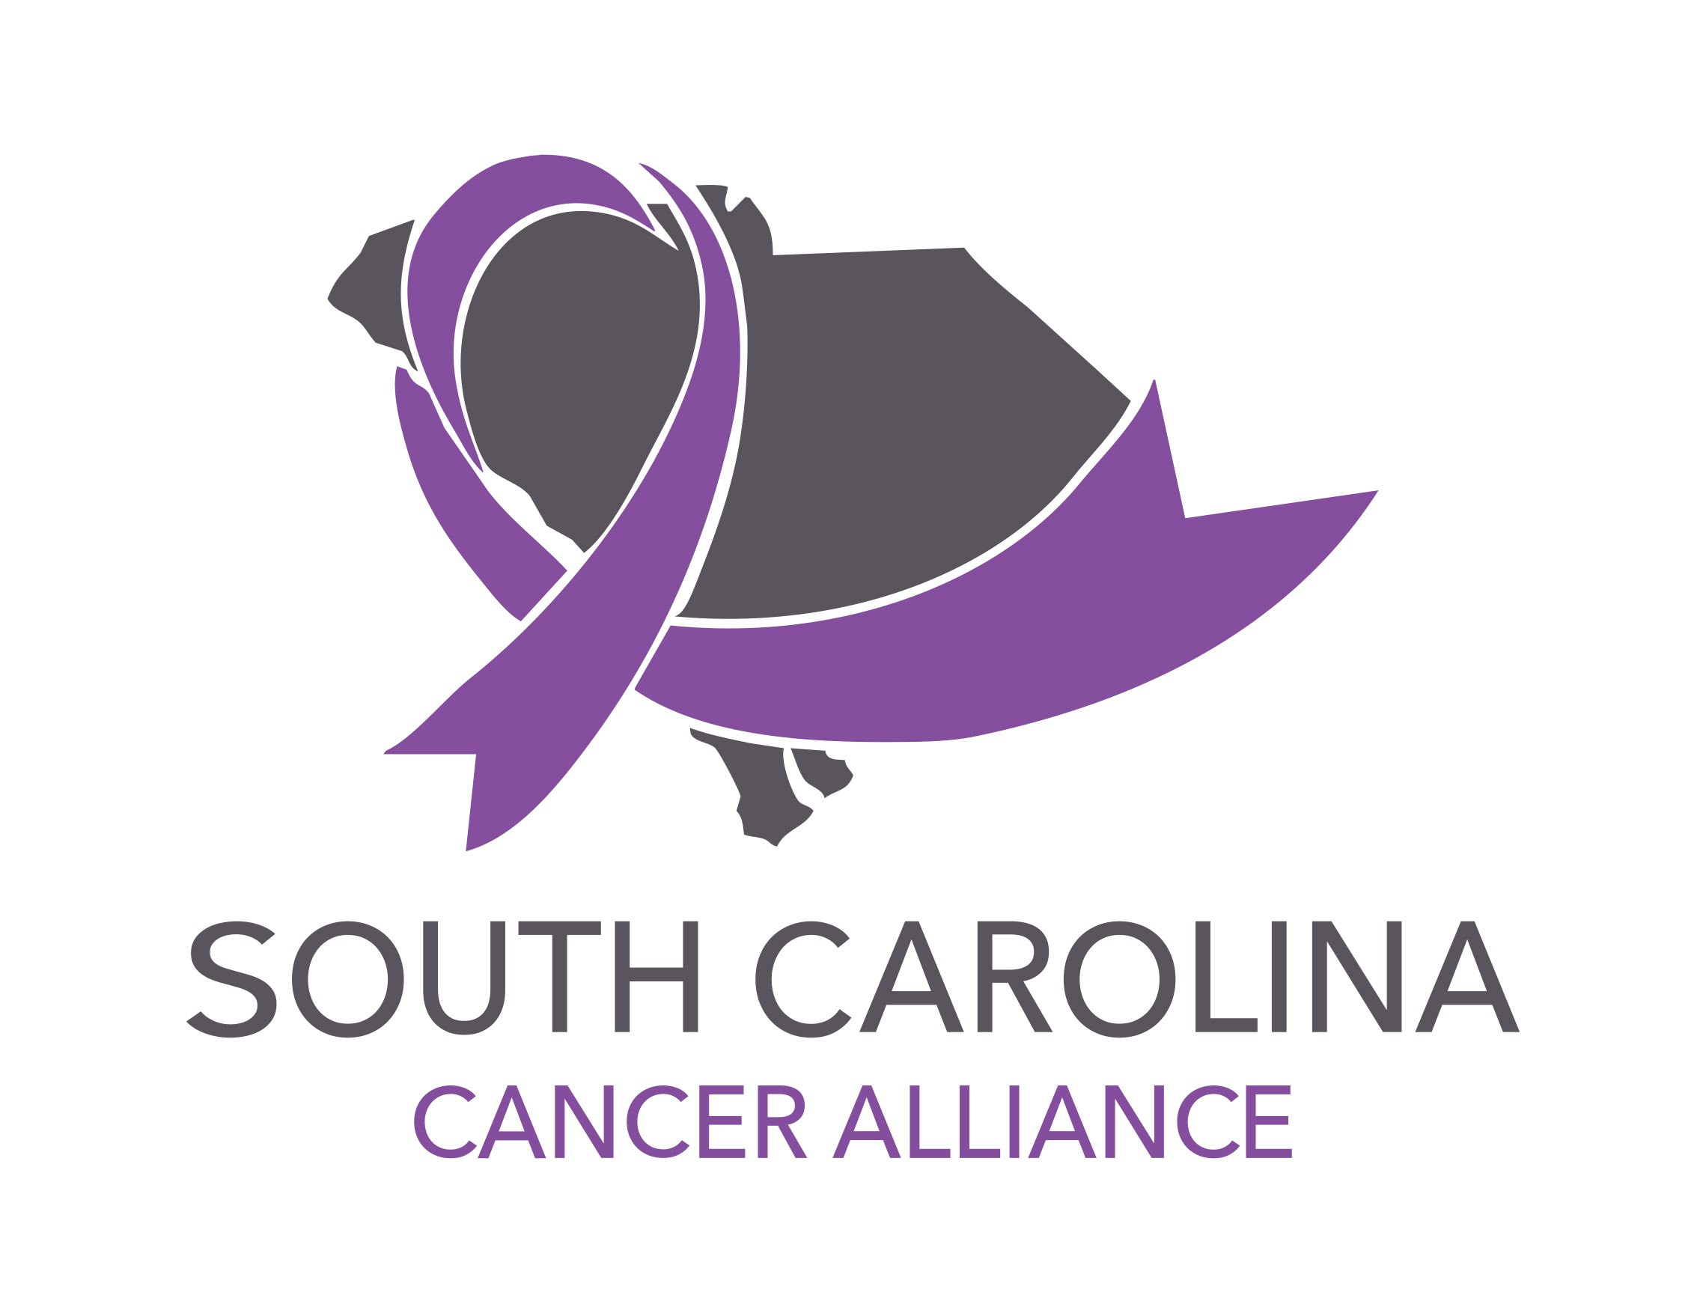
Corporate Wellness Evidence Academy
May 21, 2019
9:30 a.m. - 2:30 p.m.

9:30 a.m.: Welcome and Introduction
Henry Well/South Carolina Cancer Alliance

9:45 a.m.: Wellbeing as Its Own Incentive
Brian Passon/Arch Health and Production

12:00 p.m.: Lunch

12:30 p.m.: Wage Matters: Healthcare Utilization Patterns among Workers with Employer-Sponsored Health Benefits
Bruce Sherman, MD/Chief Medical Officer, National Alliance of Healthcare Purchaser Coalitions

1:15 p.m.: Break

1:20 p.m.:
Jen Wright, MPH/South Carolina Hospital Association - Working Well

2:05 p.m.: Closing
Henry Well/South Carolina Cancer Alliance

